
Euromech colloquium 665
Data-driven active control in flows: from model-based to reinforcement learning methods
8-10 June 2026, Paris, France

Abstract Title Here
Author Name(s)1,2
¹ Affiliation 1, ² Affiliation 2
Corresponding author: Author Name (email@example.com)

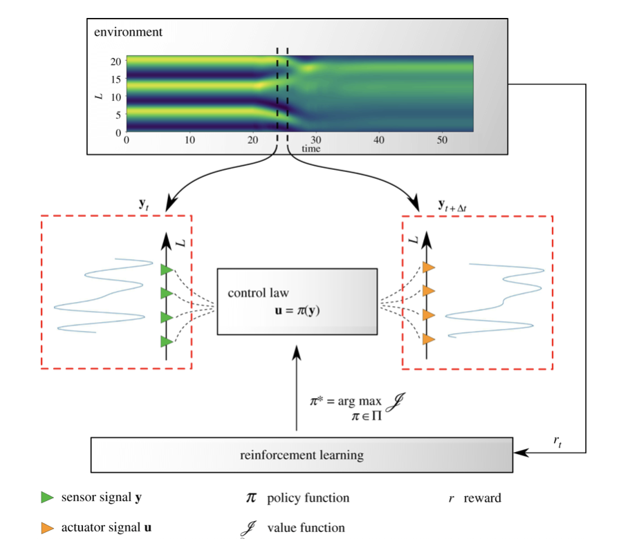
Your abstract text goes here. The maximum limit is 1 page. This is a placeholder for the abstract content, which should provide a concise summary of the main points of your research, including the background, methods, results, and conclusions. This is a sample abstract where we cite a reference [1].

Figure 1: Sample figure caption, see [2].

References
[1] Author A and Author B. Title of the paper. Journal Name, 42(5):123–456, 2023.
[2] Author C. Title of the book. Publisher Name, City Name, 2021.

